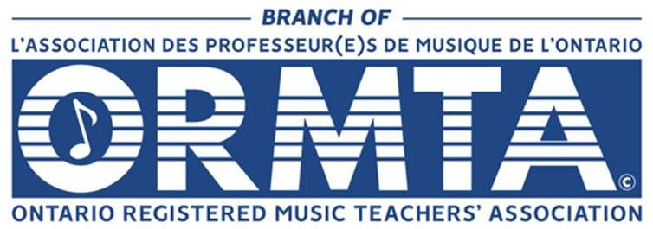

ETOBICOKE-MISSISSAUGA
ASSESSMENTS RULES

Photocopied music is NOT permitted.
  - Pianists and other instrumental entrants, without an accompanist, must provide an original manuscript of their music for the adjudicator.
  - Singers and other instrumentalists, with an accompanist, must provide 1 original manuscript of their music:

Memorization is encouraged.
  - With the exception of duet and trio entrants who are allowed to use music, solo entrants, performing with their music, will be penalized 2 marks.

Selections may be chosen from the current or past Syllabi of:
  - The Royal Conservatory of Music; Conservatory Canada; Contemporary Showcase and Suzuki
  - Pieces other than those on the above syllabi should be:
    - graded by the teacher, but are subject to the adjudicator considering them to be appropriate for the level.
    - identified on the entry form.
- Minimum entry level: Preparatory

Level 10 & up Instrumental entrants:
  - Complete performance of each selection as listed in the chosen syllabus is required. For example, both Prelude AND Fugue from the Well-tempered Clavier, or any 2 from Barber’s Excursions op. 20.
  - Exception: Due to time constraints, one movement of a Classical Sonata will count as 1 piece.

Duet and Trio Classes:
  - Each person in the same ensemble must be in the level of the class entered.
- Eligibility: Students who have OR have not secured entry into the branch competitions in the fall will be permitted entry into the March assessments. The same piece(s) cannot be performed again in a subsequent assessment in that same year. A competition year runs from September to May.

- Mature Classes (NEW): Classes for mature students are available in the fall/winter assessments for all disciplines. Over 19 years will be considered eligible for these classes. Memory is not required. Marks are not allotted, and these students will not be eligible for the branch competitions.

Recording guidelines:
  - Permitted:
    - Parents recording the performance of their child for their own personal use.
  - Prohibited:

    - Recording entrants other than one’s own child.
    - Recording adjudicator comments.
- The decision of the adjudicator is final.

